
GENBE302 – BASICS OF ELECTRICITY

DATE: …/…/2025

PERIOD: …………….

TECHNICAL SECONDARY SCHOOLS (TSS)
END OF TERM II EXAMINATIONS: 2024-2025
QUESTION PAPER
SECTOR: ICT AND Multimedia

TRADE NAME: Networking and Internet Technologies
RQF LEVEL: 3
MODULE TITLE: BASICS OF ELECTRICITY
…………/100
MARKS:
DURATION: 3 HOURS
INSTRUCTIONS TO CANDIDATES:
This Exam paper is composed of Twenty-four (24) questions distributed in Three Sections (A, B, C). Follow the instructions given below, and answer the indicated questions in each section for a total of 100marks
Section A: Between (11-17) questions, all are Compulsory. 55 marks
Section B: Five (5) questions, choose and answer any three (3). 30 marks
Section C: Two (2) questions, choose and answer any one (1) 15 marks

Allowed Materials: Blue pen, Ruler, Calculator, Pencil, (Fitting with the exam paper)

 | What is the unit of electric current?  a) Volt  b) Ampere  c) Ohm  d) Watt | (2Marks)
 | Which of the following is true about Ohm's Law?  a) V=I×RV = I \times RV=I×R  b) P=I×RP = I \times RP=I×R  c) I=V×RI = V \times RI=V×R  d) V=I+RV = I + RV=I+R | (2Marks)
 | Which of the following is NOT a type of electric waveform?  a) Sine wave  b) Square wave  c) Circular wave  d) Sawtooth wave | (2Marks)
 | What is the peak value of an AC voltage waveform with an RMS value of 10V?  a) 10V  b) 14.14V  c) 20V  d) 7.07V | (2Marks)
 | Kirchhoff's Current Law (KCL) states that:  a) The sum of all voltages around a closed loop equals zero.  b) The sum of currents entering a junction equals the sum of currents leaving.  c) The sum of all powers in a circuit equals zero.  d) The current is inversely proportional to the resistance. | (2Marks)
 | Which theorem states that the maximum power is transferred when the load resistance equals the source resistance?  a) Thevenin's Theorem  b) Norton’s Theorem  c) Superposition Theorem  d) Maximum Power Transfer Theorem | (2Marks)
 | In a series RLC circuit, what happens when the circuit reaches resonance?  a) The impedance is zero.  b) The current is maximum.  c) The voltage is zero.  d) The phase angle is 90°. | (2Marks)
 | What is the unit of power in an electrical circuit?  a) Ohm  b) Volt  c) Ampere  d) Watt | (2Marks)
 | Which of the following materials is considered ferromagnetic?  a) Aluminum  b) Copper  c) Iron  d) Gold | (2Marks)
 | What is the primary function of a transformer?  a) To store energy  b) To increase or decrease voltage  c) To convert DC to AC  d) To generate electricity | (2Marks)
 | True or False  The unit of electric current is Ampere. | (3Marks)
 | True or False  In a parallel RLC circuit, resonance occurs when the impedance is at its maximum. | (3Marks)
 | True or False  Kirchhoff’s Voltage Law states that the sum of all currents in a circuit must be equal to zero. | (3Marks)
 | True or False  A step-up transformer increases voltage and decreases current. | (3Marks)
 | True or False  The RMS value of an AC waveform is the same as its peak value. | (3Marks)
 | Match the term to the correct definition. | (10Marks)
  Term | Definition
  1. Ohm’s Law | a) The sum of voltages around a loop equals zero.
  2. Kirchhoff’s Voltage Law | b) Relationship between voltage, current, and resistance in a circuit.
  3. Peak Value | c) The maximum value of an AC waveform.
  4. Resonance in RLC Circuits | d) Occurs when the impedance is at a minimum in a parallel RLC circuit.
  5. Thevenin’s Theorem | e) Replaces a complex network with a single voltage source and series resistance.
 | Match electrical quantities with their definitions in a table below | (10Marks)
  ANSWERS ELECTRICAL | ANSWERS ELECTRICAL | ANSWERS ELECTRICAL
  1……… | 1. Power | A. describes the “pressure” that pushes electricity
  2……… | 2. Energy | B. refers to the flow of electricity in an electronic circuit, and to the amount of electricity flowing through a circuit.
  3…… | 3. Voltage | C. is a measure of the opposition to current flow in an electrical circuit.
   |  | D. is the power an atom's charged particles have to cause an action or move an object.
   |  | E. measures the rate of electrical energy transfer by an electric circuit per unit of time.

 | In the combination circuit sketched below, find:  - The equivalent resistance for the circuit.  - The total current through the circuit.  The current through each individual resistor  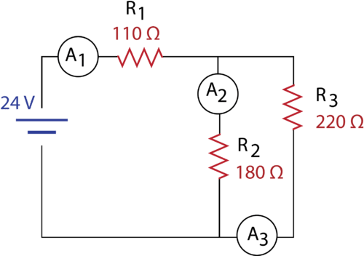 | (10marks)
 | In the following schematic diagram, find the total current (I).  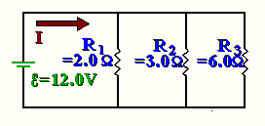 | (10marks)
 | A 100 W electric light bulb is connected to a 250 V supply. Determine (a) the current flowing in the bulb, and (b) the resistance of the bulb | (10marks)
 | Explain The main characteristics of a series circuit | (10marks)
 | For the circuit shown in Figure below, determine (a) the battery voltage V, (b) the total resistance of the circuit, and (c) the values of resistance of resistors R1, R2 and R3, given that the  p.d.’s across R1, R2 and R3 are 5 V, 2 V and 6 V respectively.  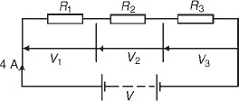 | (10marks)

 | Determine the current in the 5Ω resistance of the network shown in Figure below using Norton’s theorem and Thevenin’s theorem. Hence find the currents flowing in the other two branches  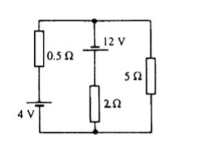 | (15marks)
 | Figure below shows a circuit containing two sources of e.m.f., each with their internal resistance. Determine the current in each branch of the network by using the superposition theorem.  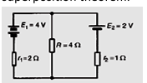 | (15marks)

________________END OF ASSESSMENT_______________

